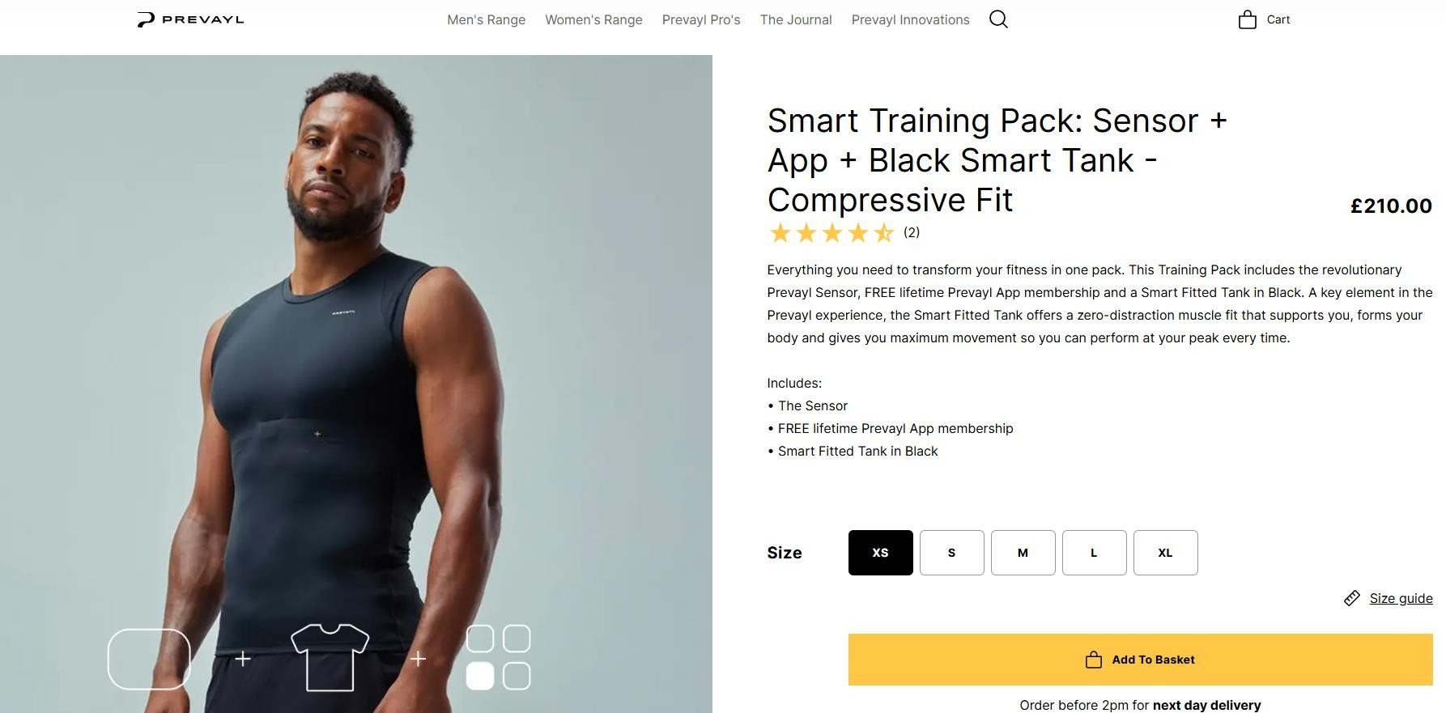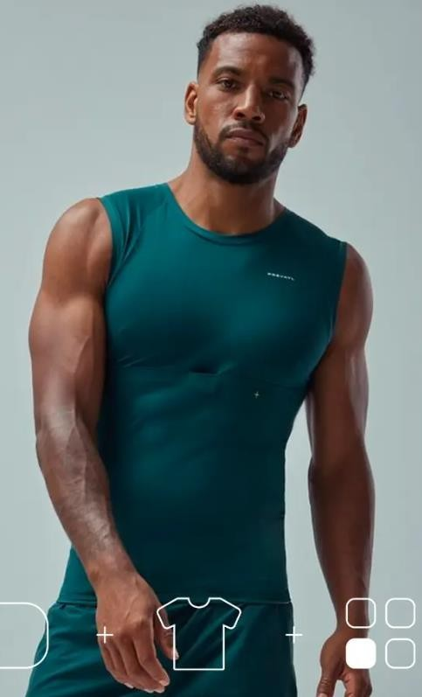

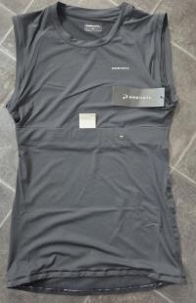
Please note these are just the Tanks
2,003pcs x Prevayl Smart Training Fitted Tank…….RRP £75………
Black - | XS – 35pcs | M – 607pcs | L – 637pcs | XL – 261pcs
Green - | M – 387pcs | XL – 76pcs

Breakdown;

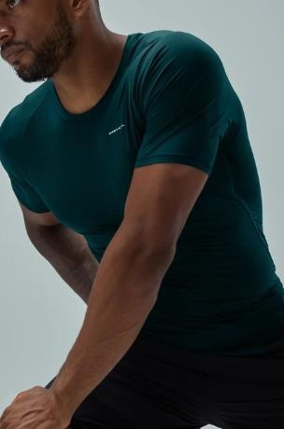

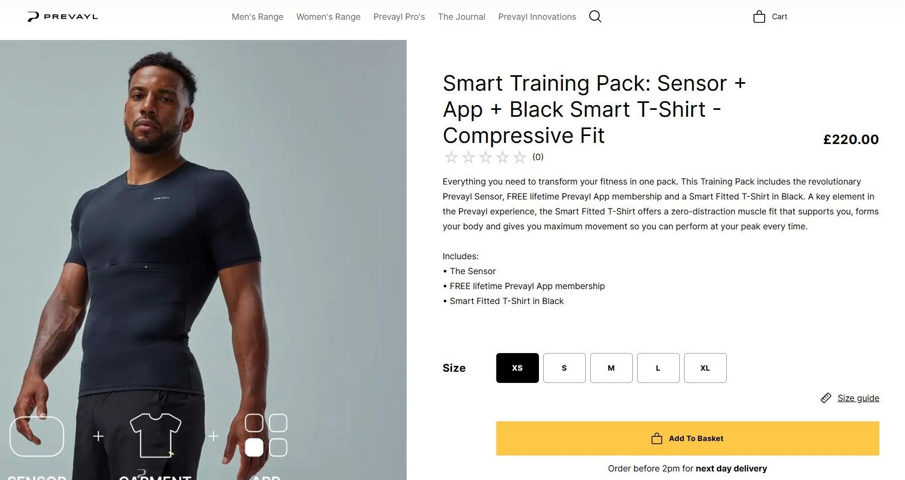
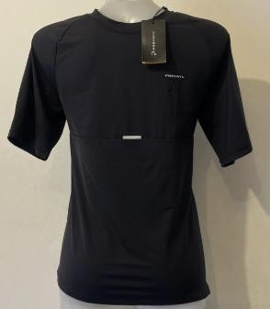
Please note these are just the smart fitted T-Shirt
3,322pcs x Prevayl Short Sleeve Compression Fit Base Layer…..RRP £75……
Breakdown;
Black - XS – 21pcs S – 5pcs M – 674pcs L – 1,350pcs XL – 475pcs Pine Green - XS – 15pcs S – 40pcs M – 366pcs L – 278pcs XL – 98pcs

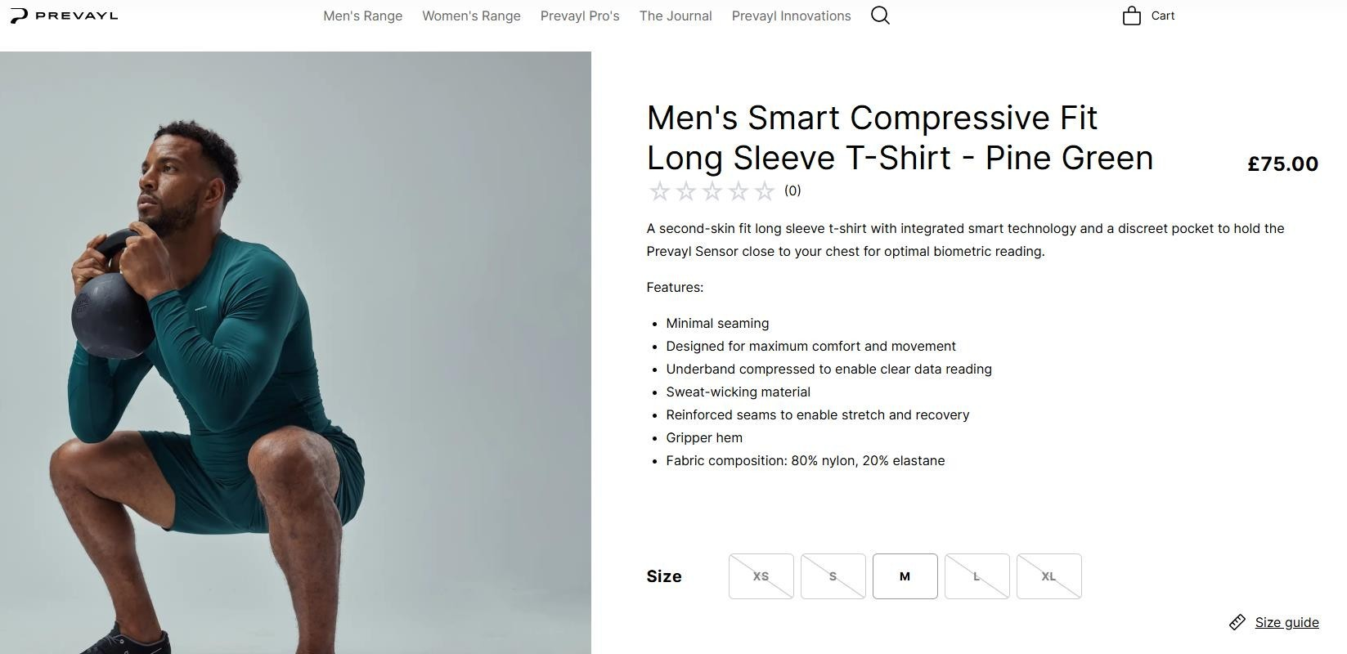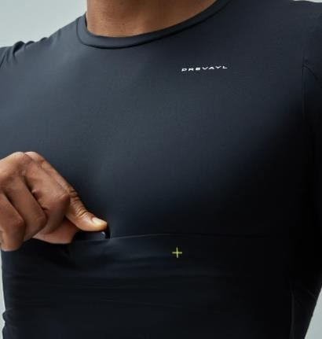

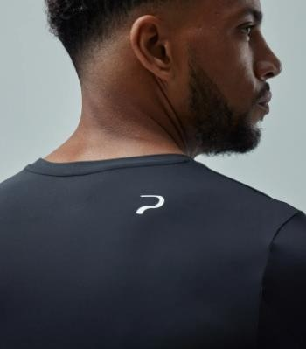
Please note it is just the Compressive Long Sleeve T-Shirt
960pcs x Prevayl Men’s Smart Compressive Fit Long Sleeve T-Shirt……….RRP £75…

Breakdown;

Black - | S – 69pcs | M – 320pcs | L – 140pcs | XL – 22pcs
Green - | S – 58pcs | M – 190pcs | L – 161pcs

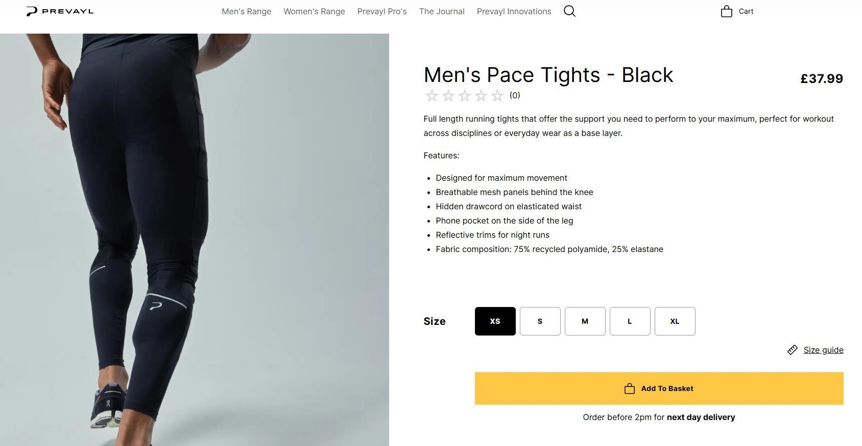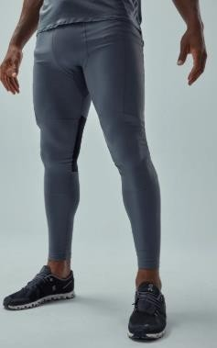

1,372pcs x Prevayl Men’s Pace Tights – Black………RRP £37.99

Breakdown;
Black - XS – 47pcs S – 140pcs M – 212pcs L – 323pcs XL – 145pcs Iron Grey - XS – 33pcs S – 90pcs M – 100pcs L – 184pcs XL – 98pcs

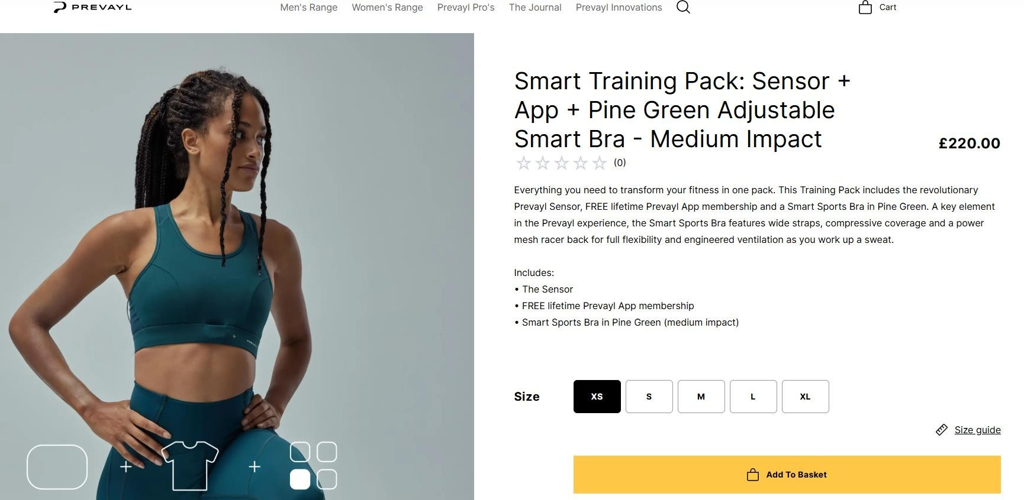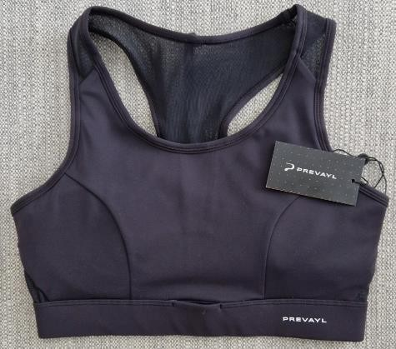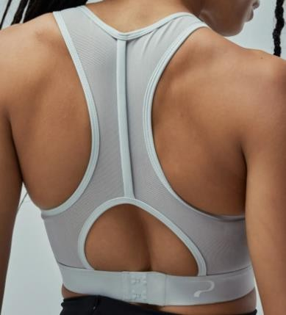

Please note it is just the sports Bra
1,668pcs x Prevayl Adjustable Smart Bra – Medium Impact…….RRP £65………
Breakdown;
Black - XS – 178pcs S – 289pcs M – 384pcs L – 233pcs XL – 43pcs Green - XS – 27pcs S – 100pcs M – 65pcs L – 90pcs XL – 17pcs
Lunar Grey - XS – 48pcs S – 22pcs M – 12pcs L – 121pcs XL – 39pcs

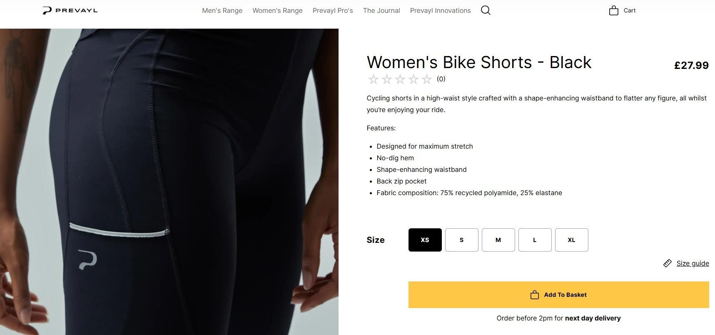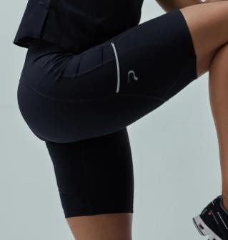

71pcs x Prevayl Women’s Bike Shorts – Black……….RRP £27.99…

Breakdown;
S – 1pc M – 70pcs

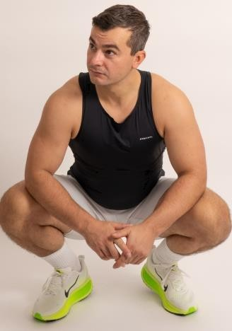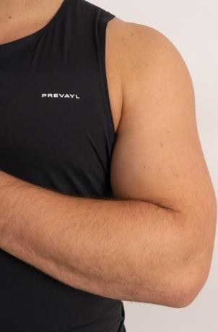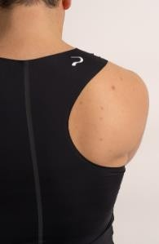

721pcs x Prevayl Racer Tank Top………RRP £60………
Breakdown;
Black - S – 110pcs M – 306pcs L – 250pcs XL – 55pcs

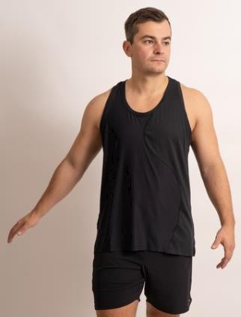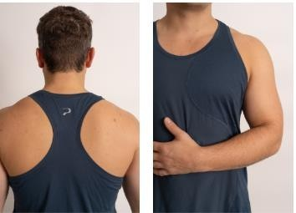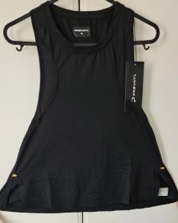

425pcs x Prevayl Ebb Vest………RRP £70

Breakdown;
Black – XS – 42pcs S – 110pcs M – 36pcs L – 89pcs Blue - XS – 20pcs S – 50pcs M – 48pcs L – 30pcs

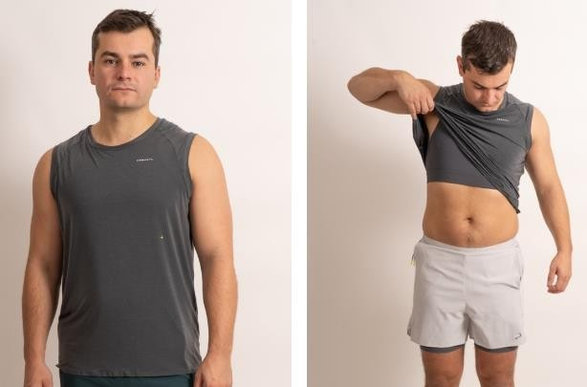

611pcs x Mens 2-in-1 Performance Tank Top……….RRP £60…

Breakdown;
M – 229pcs L – 322pcs XL – 60pcs

